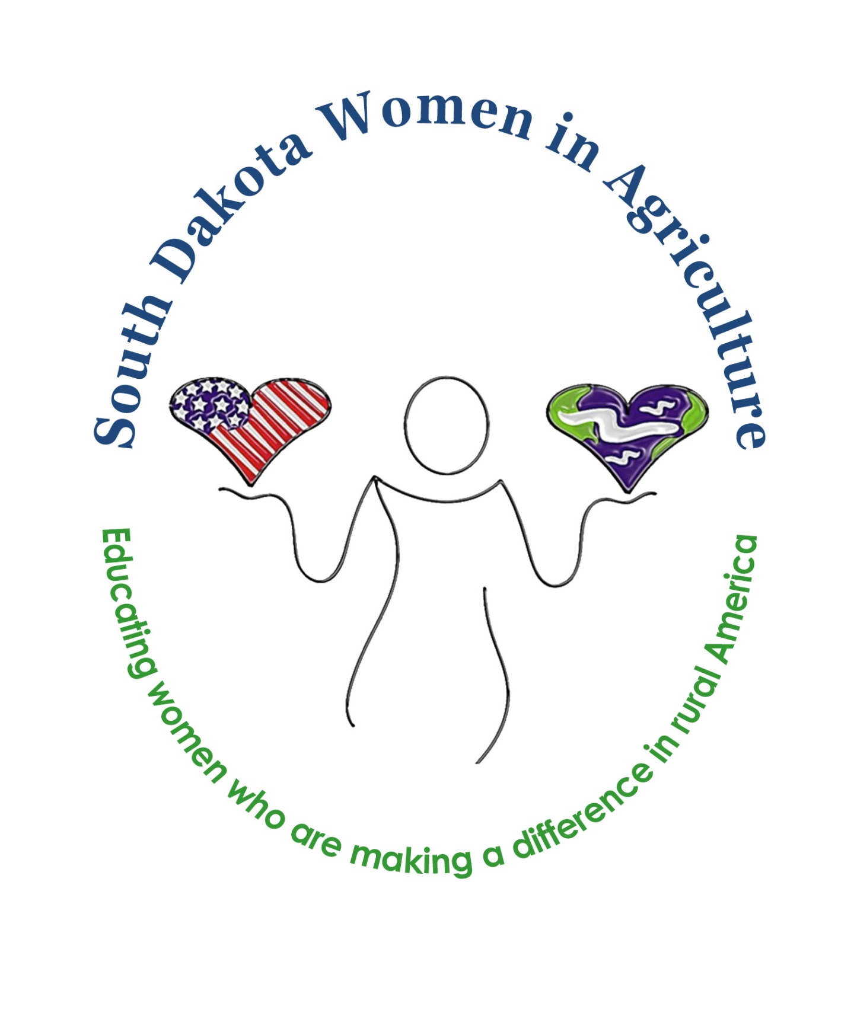
Hello from the South Dakota Women in Ag Board:

We are looking forward to the 2021 Rural Women in Agriculture conference to be held on October 7 & 8, 2021 at The Lodge, in Deadwood, South Dakota. As a non-profit organization, South Dakota Women in Agriculture depends on support like yours to make this conference possible and continue with our mission: to educate women who are making a difference in Rural America. This year’s conference will include:
- a beef industry panel discussion
- a look into life along the Mexican border
- a perspective from a local restauranteur
- emergency conservation funding and more!

Please consider being a part of our conference with your generous tax-deductible support.

For a contribution of $1000 or more (Gold Level Sponsor), you will receive:
- 2 Complimentary Conference Registrations
- Organization/Business brochure included in conference packet
- Your business highlighted as sponsor on the SDWIA website, social media and at the conference

For a contribution of $500 (Silver Level Sponsor), you will receive:
- 1 Complimentary Conference Registration
- Your business highlighted as sponsor on the SDWIA website, social media and at the conference

For a contribution of $250 (Bronze Level Sponsor), you will receive:
- Your business highlighted as sponsor on the SDWIA website, social media and at the conference

Design Your Own Sponsorship:
Interested in sponsoring a meal or t-shirts? Want to provide a speaker for our conference? Have another idea for sponsorship? Please feel free to call or email me. Jenn Stomprud 605-877-0136 jastomprud4@hotmail.com

Be a Conference Contributor:
Want to donate an item or service for our silent auction? Or wish to help our in another way? We would love to have you as a contributor.

We appreciate your support! Checks Payable to: SD Women In Ag
Jenn Stomprud Mail to: Attn: Ann Mackaben, Treasurer
Conference Chair South Dakota Women in Agriculture
jastomprud4@hotmail.com PO Box 44
605-877-0136 Sturgis, SD 57785
---------------------------------------------------------------------------------------------------------------------------------------
Please return with sponsorship. Thank you for your support!
Name of Business: ________________________________________________________________________________
Name of Contact: _________________________________________________________________________________
Phone: _____________________________________ Email: _______________________________________
Address: ________________________________________________________________________________________
City: ________________________________________________ State: ______________ Zip: _______________
Level of sponsorship: Gold:____ Silver: ____ Bronze: ____ Contributor: ____ Design your own: ____

