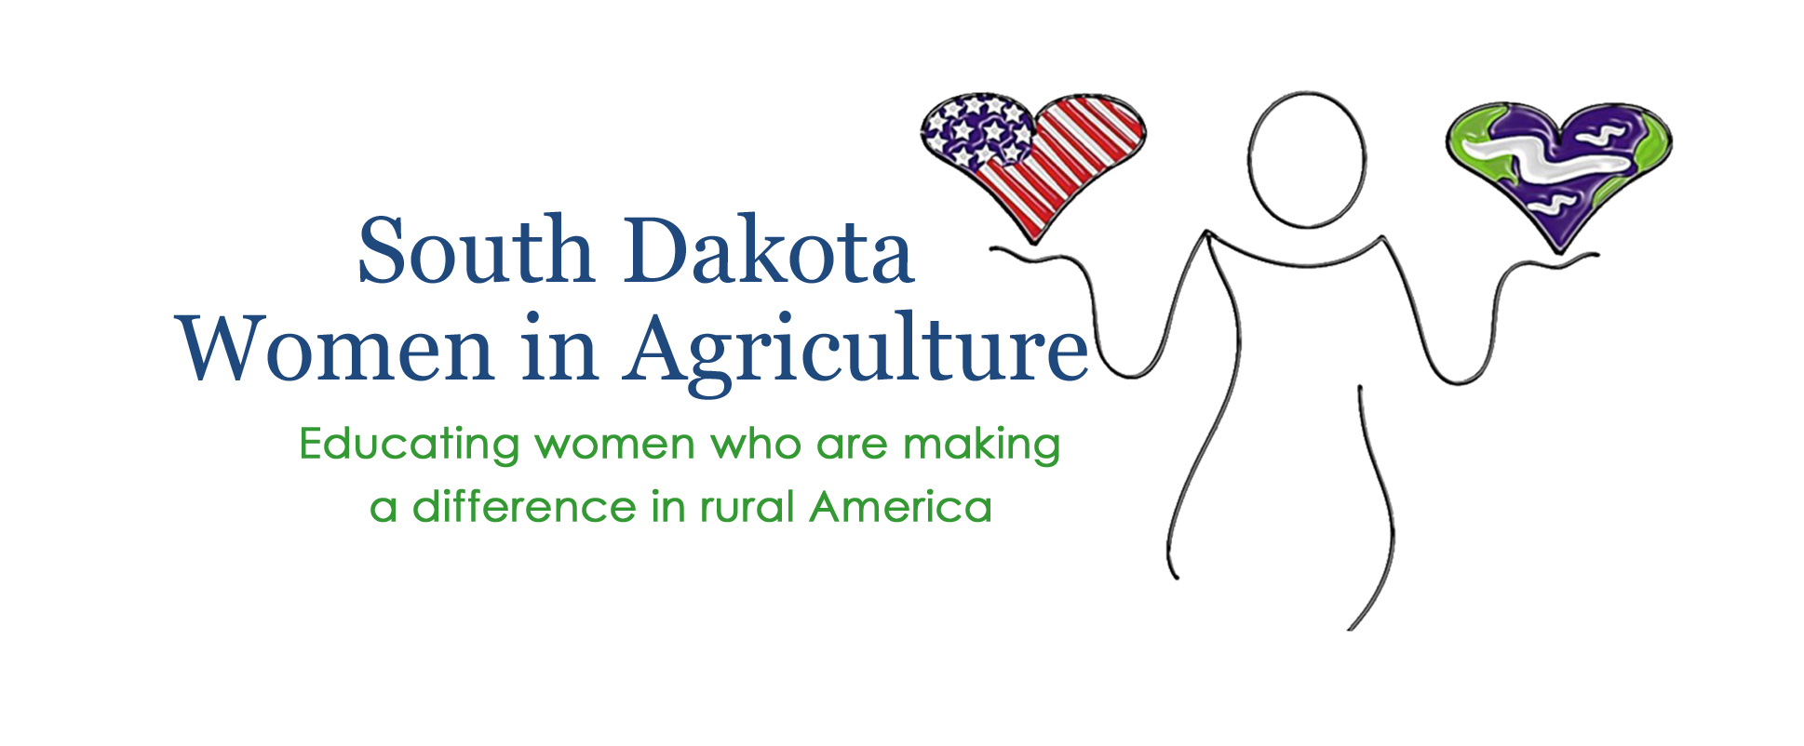

Hello from the South Dakota Women in Ag Board:

We are excited to invite you to be part of the Rural Women’s Conference to be hosted by South Dakota Women in Ag Oct. 10-11 in beautiful Deadwood. Our mission remains to Educate Women Who are “Making a Difference” in Rural America and we plan to do so in 2019 with your support.

With an ever-growing attendance, this year’s conference will again be held at The Lodge in Deadwood. This year’s theme is "Living the Ag Life" with a focus on wellness for the people, animals, land and agricultural industry.

Last year's amazing speakers brought our group information on developing a personal brand, low stress cattle handling, the Farm Bill, Ag in a box and even some cowgirl poetry and music. Women from across the state went home informed, encouraged and motivated.

As a non-profit organization, this conference is made possible through support like yours. We hope you will consider being a part of our 2019 conference. Included are the sponsorship levels for the 2019 conference. We appreciate you taking time to consider supporting South Dakota Women in Agriculture.

Jenn Stomprud
South Dakota Women in Ag
PO Box, 44, Sturgis, SD 57785
605-877-0136
sdwia@outlook.com
Find us online at www.southdakotawomeninag.com
Like us on Facebook

